OB856 Guide

Before starting any development you will need two documents:

* EDI Specification Document
* Partner Connectivity Information

When you have the documents you can begin development.

Partner Profile Configuration

This will need to be set up in each environment to complete profile set up. Go to Dev MyWebMethods and navigate to the partner profile page (Administration > Integration > B2B > Partner Administration > Partner Profiles). Click the add Profile button on the top left side of the page. Fill in the Corporation Name whose profile you are setting up, the organization name(WWT), and set the status to Active.

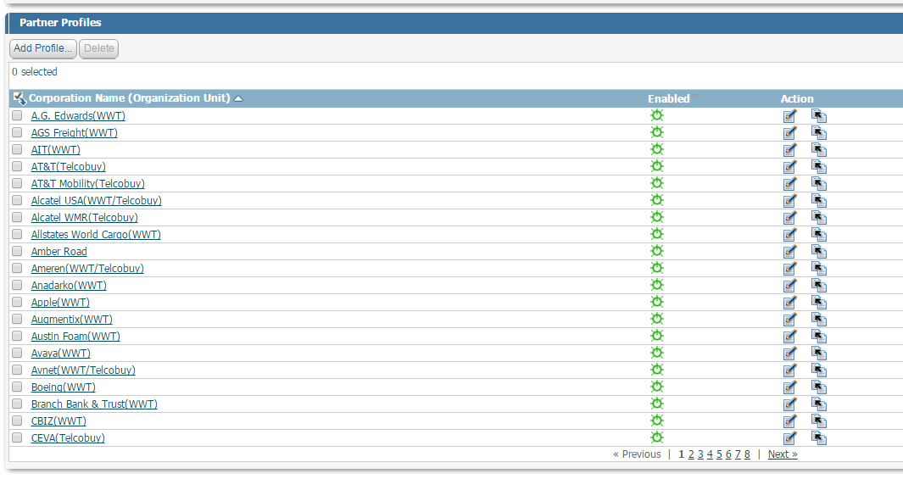

The rest of the information for the partner profile will be provided in the partner connectivity document. You can use AIT or any other EDI partner profile as a template. The certificate may or may not have been provided with the connectivity information. If not, you will need to ask the partner for their certificate.

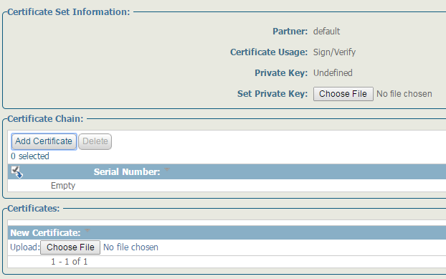

Once on the certificate page, click on the sign/verify link and it will bring you to the edit certificate page. You should then choose the certificate under the choose file option in the certificates sub category. Do the same for the sign/encrypt section if it did not load automatically. Now copy the partner profile set up into the TEST environment.

Test Connectivity with Partner

This should all be done in the TEST environment. We should now test connectivity with the partner. Set up a time in which you can send and receive a test 997 with the partner. This is all done in TEST MyWebMethods. We will first send them a test 997. Navigate to the transactions page in MWS( Monitoring > Integration > B2B > Transactions). Query the transactions by document type equals X12 4010 997. 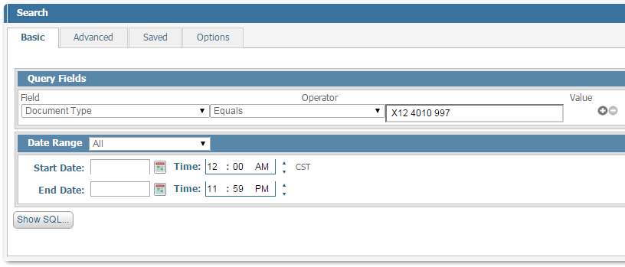

Select the content of any 997 in which WWT is the Sender by clicking the magnifying glass under the details column of the record. Then click the content tab in the transaction details on the bottom of the page and we can use that 997. Make sure you change ISA 08 and GS 03 to the partners test ID. Then navigate to the submit documents page ( Administration > Integration > B2B Settings > Submit Documents ).

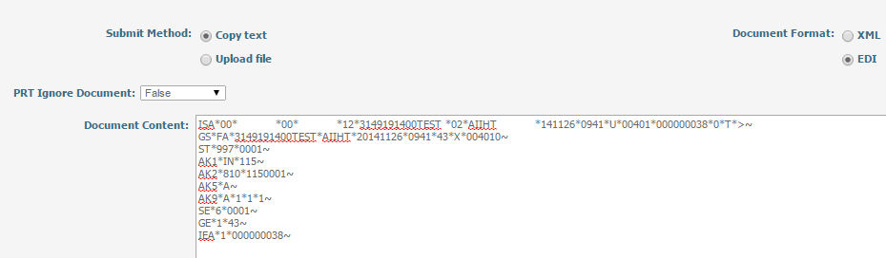Paste the 997 into the Document Content field, change the document format to EDI, and then hit submit. If this was successful, you will see a 997 sent out and MDN received on the transactions page. The troubleshooting for this will be done in the partner profile set up. When the partner sends us a 997, an MDN should be automatically sent to them which can be seen on the transactions page.

Lookup Configuration

There are a total of seven lookups we will need to set up for this process. The lookups include: DUPLICATE_CHECKING, EDIINT, FA_PROCESSING, GS_ENVELOPE, ISA_ENVELOPE, WWT_ASN_OUTBOUND_EXTRACT, WWT_WM95_EDI_PARTNERS. The first five lookups are part of the ‘EDI’ lookup group.

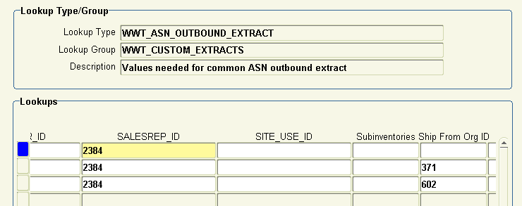

* WWT_ASN_OUTBOUND_EXTRACT – This lookup drives the ASN process for both the XML and EDI processes. You will need to enter EDI for the communication method, ‘UNPROCESSED’ for insert status, the partner ID, and a unique combination of Customer_ID, SalesRep_ID, and Ship_From_Org_ID. You can use any combination of the previous three values as long as it is unique to the partner. You can query ‘%Sprint%’ in the description column and use the results as a template.
* DUPLICATE_CHECKING –This lookup will make sure you don’t create multiple 856s for the same order. We will need to insert three new records in this lookup. One for dev, test, and prod. The TP EDI ID column is the EDI ID specified in the partner connectivity information(use test ID for dev). The ISA dup check flag will check if there has been an identical ISA on a previous 856. We want to set this to false for dev and test so we can reuse the same test data. This should be set to true for Prod. The GS dup column should be treated the same way except it checks for an identical GS. You can query the description column for ‘AIT’ and use that as a template.
* EDIINT – This lookup is configuration info for the EDIINT process. You will need to insert three new records for dev, test, and prod. TN PartnerID column is the value you specified as the external ID in the partner profile section of TN. Type should stay as getFromProfile. Compressed should be false. Delivery method, Request MDN, Rec AS2 ID, and Rec AS2 Desc will be specified in the Partner Connectivity Information document. Send AS2 ID should be set to 614948396 for prod and 614948396T for dev and test. Send AS2 DESC should be set to EDIINT AS2. You can query the description column for ‘AIT’ and use that as a template.
* FA_PROCESSING - You can query the description column for ‘AIT’ and use that as a template.
* GS_ENVELOPE – Three new records for dev, test, and prod. ERP TP Code, ISA_08, and GS_03 and the IDs specified in the Partner Connectivity Information. Keep GS C# From Table Flag and GS C# Leading Zeroes Flag as true. You can query the description column for ‘AIT’ and use that as a template.
* ISA_ENVELOPE – ISA 07 is the interchange ID qualifier which will be specified in the Connectivity Information ISA 08 is the EDI Partner ID from the connectivity information. Keep GS C# From Table Flag and GS C# Leading Zeroes Flag as true. Set Transport to hold for dev and to EDIINT Direct for test and prod.

EDI Mappings

We will now need to create the EDI Mappings which will be the template for creating the 856 itself.

.cert

Need -> CVS, MWS, an Editor, Oracle Access

